The Unveiling Ceremony of the Affiliated Senior High School of National Chung Hsing University and the Affiliated Taichung Agricultural Senior High School of National Chung Hsing University
(Written by Cong-Fu, Lin)
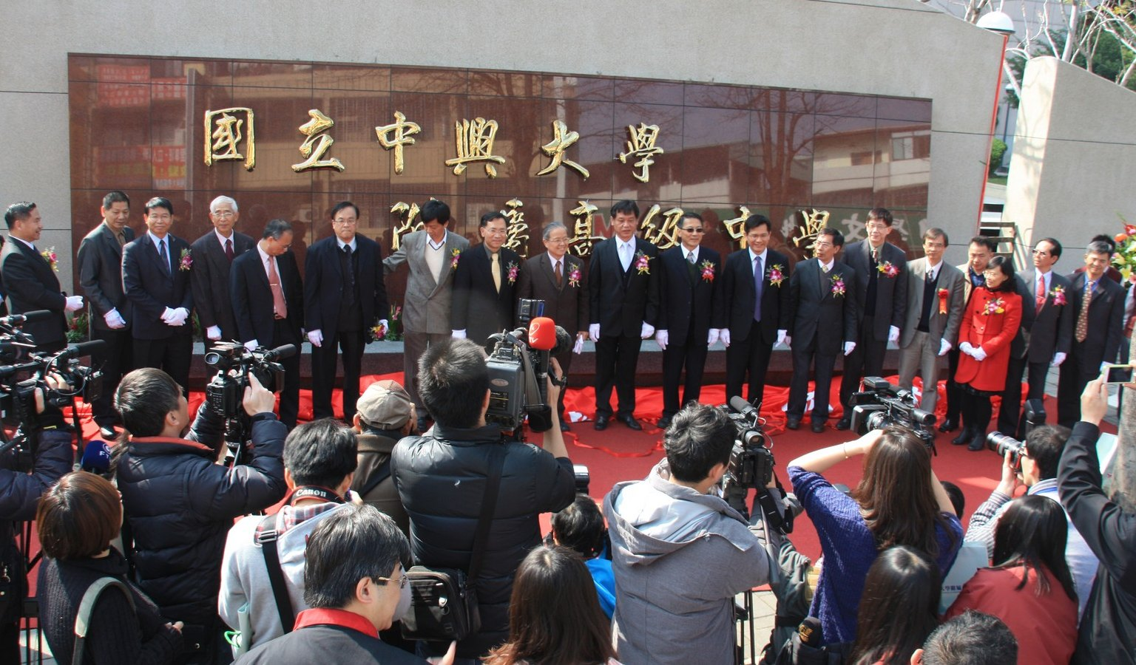
The ministry of Education approved the affiliation of National Dali Senior High School (hereinafter referred to as NDSHS) and National Taichung Agricultural Senior High School (hereinafter NTASHS) to be affiliated to National Chung Hsing University on February 1, 2014. The two schools were renamed as the Affiliated Senior High School of National Chung Hsing University and the Affiliated Taichung Agricultural Senior High School of National Chung Hsing University. The unveiling ceremony was held on February 21. The affiliation is expected to improve teaching quality and educational practicum, and to enhance educational research and competitiveness of the two schools.
In 2006, NDSHS and NTASHS signed a strategic alliance cooperation agreement with National Chung Hsing University to exchange ideas of managing academic affairs, student affairs, general affairs, student counseling, and interlibrary loans, and to share academic resources and better consultation services. After a series of meetings, public hearings, seminars, the two schools passed the decision to be affiliated to National Chung Hsing University. On their faculty meetings, both schools had an attendance of more than three quarter of their faculty members and the decision was supported by more than three quarters of the attendees.
Following the implementation of the 12-year Compulsory Education (K12 Education?), the university and the two affiliated schools are expected to provide students with an excellent learning environment and enhance the competitiveness of the three organizations by reaching the following goals:
- Incorporating educational resources and broadening cooperation;
- Strengthening the training for young talents and developing features of the schools;
- Improving teacher training and establishing fine intern programs;
- Providing teachers with diverse resources and in-service training, and strengthening their expertise to improve their teaching perfomances;
- Designing educational experiments to enhance the quality of educational research in Taiwan;
- Implementing different collaborative projects to integrate and share education resources;
- Setting good examples of collaboration among educational institutes for other similar projects;
- Attracting academic elites from home and abroad to enhance Taiwan’s competiveness;
- Promoting diversity and innovation in curriculum and fostering adaptive development.
