Expert counseling in kindergartens helps to head start early childhood education
Photo and Article by Wang Ling-yan (王令彥), Division of Junior High, Elementary School and Preschool Education
The Ministry of Education has been promoting the expert counseling program since the school year 2005, with an aim to promote career growth for preschool teachers and improve the quality of kindergarten teaching through expert counseling in the kindergartens. So far, this program is about to entered its tenth year. In order to address kindergarten counseling needs more appropriately, from the beginning of the school year 2013, K-12 Education Administration, Ministry of Education (hereinafter referred to as K-12 Education Administration) has provided different types of counseling programs tailored to the kindergarten’s needs. In addition to helping kindergartens build an adaptive learning environment, providing high-quality child care courses, the program also enables kindergartens to further develop their featured courses.

Experts in the kindergartens raise the confidence to “change”
“See through children, and learn joyfully" has been the purpose of early childhood education which is also the spirit of the recent featured flipped classroom. Teachers must design their curriculum based on children’s aptitude so that the children would love to learn and learn through playing. Based on this belief, the teachers must change their past habit, such as relying on textbooks and providing notebooks and pencils for practices, and instead focus on breaking classroom boundaries, and exploring new learning landscapes with children.
Most teachers surely like to make progress and pursue changes, but some of them are hesitate in taking the first step. Therefore, many newly founded kindergartens, as well as those who seek transformation in their teaching approaches, have participated in the counseling program, hoping it would become a tipping point, utilizing the counseling and assistance from experts and scholars as the strong backing for their pursuing of "changes" in the kindergartens.
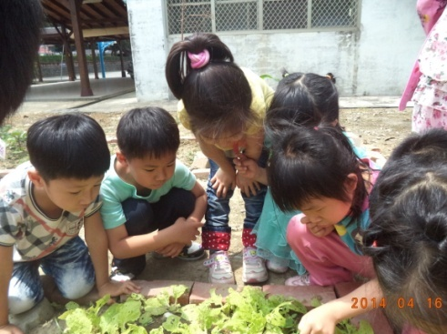 The principal of the affiliated kindergarten of Shuandong Elementary school, a small town school in remote Caotun township, Nantou County, supported its newly founded nursery school to join the counseling program. The principal believes that, through counseling with experts, the school can systematically improve its teaching quality. The professor’s observation and counseling can help teachers in several ways, such as how to record dialogue between children, how to see through children’s ideas and abilities during their discussions with children, and how to let go and let the children do it themselves.
▲The kids inaffiliated kindergarten of Shuandong Elementary school explore in the campus.
After a year, the affiliated kindergarten of Shuandong Elementary school has integrated its curriculum with local resources. The areca nuts became teaching showcases such as necklaces and spinning tops. The green campus and community streets have all become children’s classrooms. The kids chanted, “I like to go to school, because every day is an adventure!”

Practice the ability to see through children
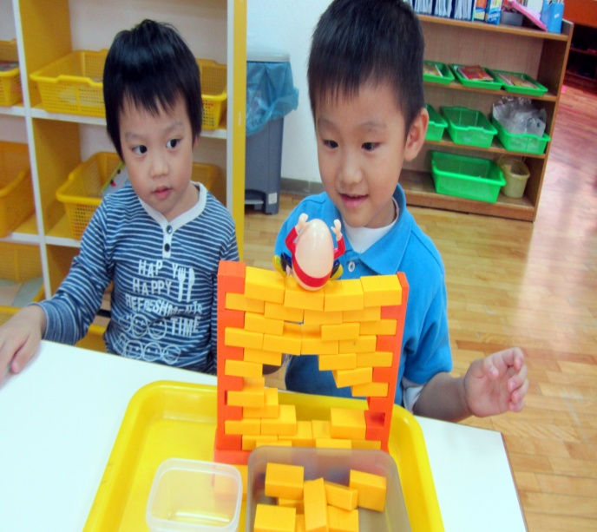For teachers, children’s simple words in the game may be the children’s desire to learn numbers, as well as other key concepts such as comparison and measurement. The best way to understand children’s development and learning are their acts in games, their words, as well as expressions and reactions.
Children have a special pattern in learning. They are naturally inclined to playing games, and can spontaneously explore, experiment and discover during playing. K-12 Education Administration tried to understand children's development and learning through empirical research and compiled temporary guidelines for kindergarten activities and curriculum, hoping to develop the child's ability through integrated curriculum. At the same time, through counseling program, the Administration invited experts to provide guidance to teachers in grasping the implications of the curriculum guidelines, seeing through children’s needs, and planning learning activities that addresses the needs of early childhood development.
▲ “See how good I am! The egg won’t fall”, said the kids in Sunshine preschool.
▲「看我的厲害，讓蛋不會掉下來!」陽光幼兒園幼兒
The nonprofit Sunshine preschool in Hsinchu City planned its two-year counseling program. The teachers can examine their own teaching process through indicators of the curriculum guidelines. It not only helps to develop children’s ability, but also helps in their exploring of integrated curriculum, through which teachers can learn new concepts in their professional development, while kids can have a great time in their learning.

Scaffolding children's learning and developing unique preschool curriculum
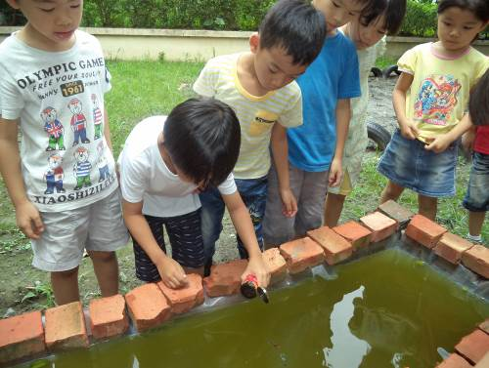 The Green Sprouts kindergarten in Taitung, which encompasses a wide natural campus, participated in the counseling program for years. Instead of relying on the traditional notebooks and pencils learning, they now focused much on the child-centered thematic curriculum. The teachers utilized the rich natural resources on campus, making it an environment where children can learn to explore. The children in junior class explored the five senses in the environment; children in intermediate class learned to observe through their hands-on activities in "planting," while children in senior class learn problem-solving and experience arts and humanities through various course topics.
▲“Our pond won’t leak and we can feed the fish”, said the kids in Green Sprout kindergarten.
With the help of counseling professors, kindergartens can provide different courses for different age groups, and develop their own featured courses. Teachers can discuss with experts through curriculum review and reflect on their curriculum concepts, teaching strategies and guiding methods. Teachers can also reflect on how to prepare the child's ability by scaffold instruction, how to guide the children so that they develop more of their abilities and think deeper.
Leading the kids out of the classroom, teachers in Green Sprouts found that courses are linked together by children's questions; and developing children's problem-solving ability has become their teaching guidelines. In addition to encouraging children to ask questions, teachers can also guide the children to ask questions based on "questions", to solve problems through raising questions, gathering information, and trying to solve it. Children asked questions such as: "Why do fish eat fish food?" and "What else do fish eat?" This summer, based on children’s interests and ideas, a fish pond was eventually designed and built by children on Green Sprouts campus!
Successful counseling in the kindergartens enables the professional growth of preschool teachers, the development of different courses for different age groups, as well as featured courses in kindergartens. The courage to "change" has become a key for successful transition and head start early childhood education in this qualitative and quantitative revolution of teachers and kindergartens.

